Guide
Week | Descriptor | Topic
2 | Numbers, operations and relationships | - Counting forward and backwards 1-50  - Identify, recognise number symbols 1-50  - Identify, recognise and read number names.
3 | Numbers, operations and relationships | - Describe, compare and order 1-30  - Compare whole numbers up to 10 using smaller than, greater than, more than, and equal to.
4 | Numbers, operations and relationships | - Recognise and identify South African money.
5 | Numbers, operations and relationships | - Addition and subtraction
6 | Space and shape (Geometry) | - Positions (On top, behind, under etc)
7 | Space and shape (Geometry) | - Follows directions to move around the classroom.
8-9 | Space and shape (Geometry) | - 3D shapes

Number chart
1 | 2 | 3 | 4 | 5 | 6 | 7 | 8 | 9 | 10
11 | 12 | 13 | 14 | 15 | 16 | 17 | 18 | 19 | 20
21 | 22 | 23 | 24 | 25 | 26 | 27 | 28 | 29 | 30
31 | 32 | 33 | 34 | 35 | 36 | 37 | 38 | 39 | 40
41 | 42 | 43 | 44 | 45 | 46 | 47 | 48 | 49 | 50
51 | 52 | 53 | 54 | 55 | 56 | 57 | 58 | 59 | 60
61 | 62 | 63 | 64 | 65 | 66 | 67 | 68 | 69 | 70
71 | 72 | 73 | 74 | 73 | 73 | 77 | 78 | 79 | 80
81 | 82 | 83 | 84 | 85 | 86 | 87 | 88 | 89 | 90
91 | 92 | 93 | 94 | 95 | 96 | 97 | 98 | 99 | 100

Introduction
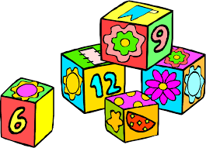

Week 2
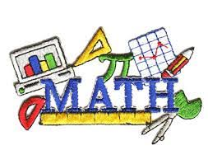

Group 1
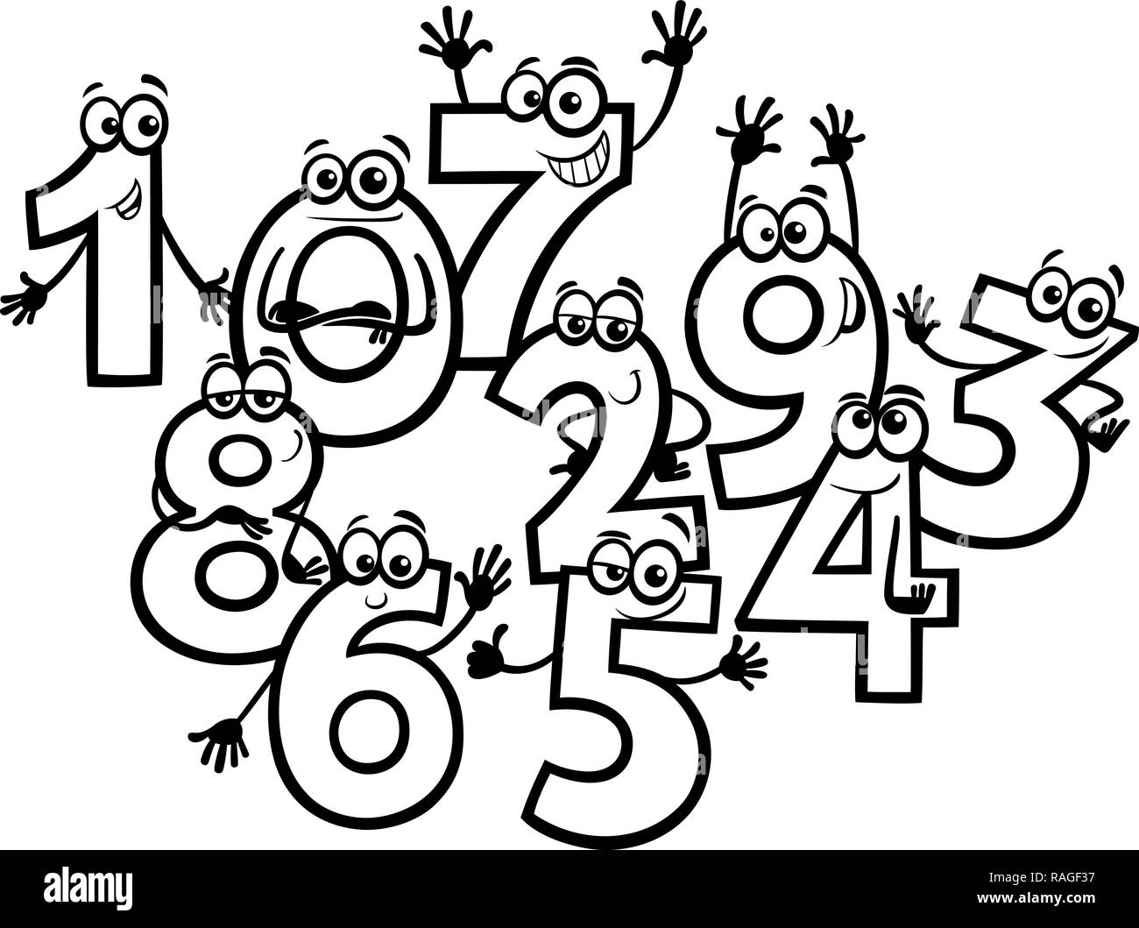

This is the number 1. There is 1 rabbit at the farm.

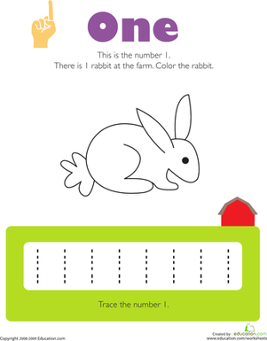

Fun with numbers
Circle the correct number
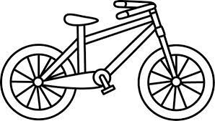

4 2 3

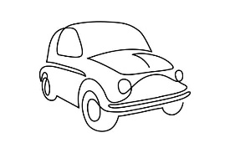
3 5 4

  4 2 1 |  | 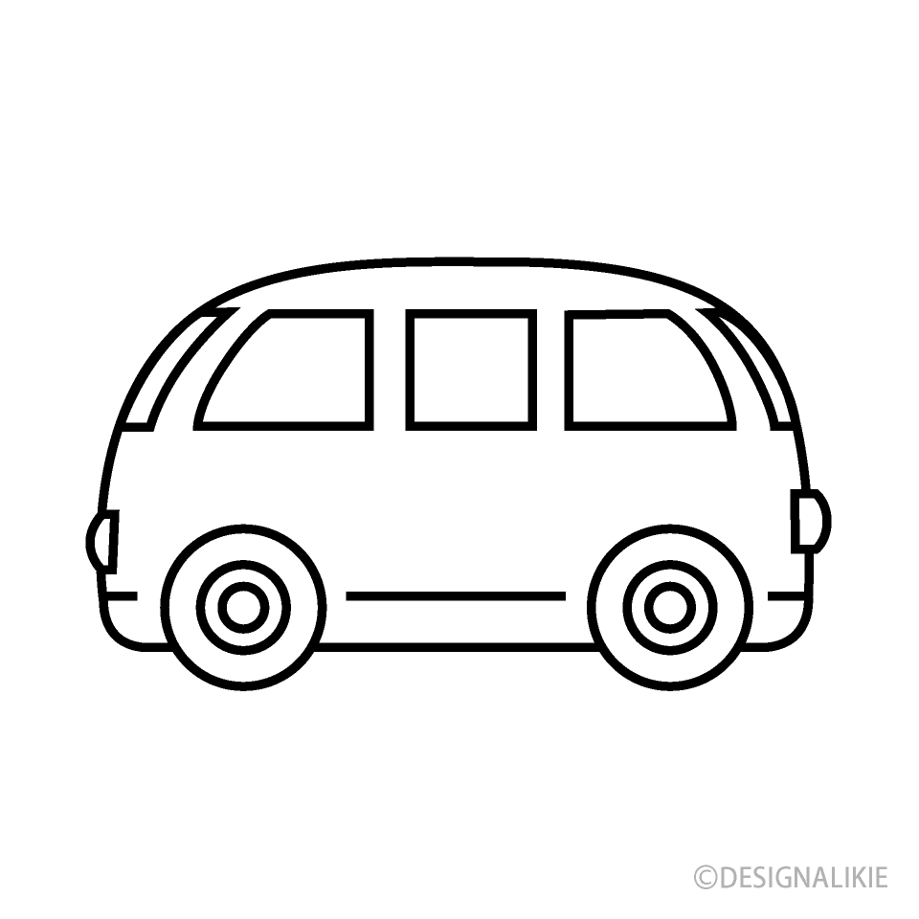  1 3 2

Match it up
Draw lines to connect the numbers and pictures that go together

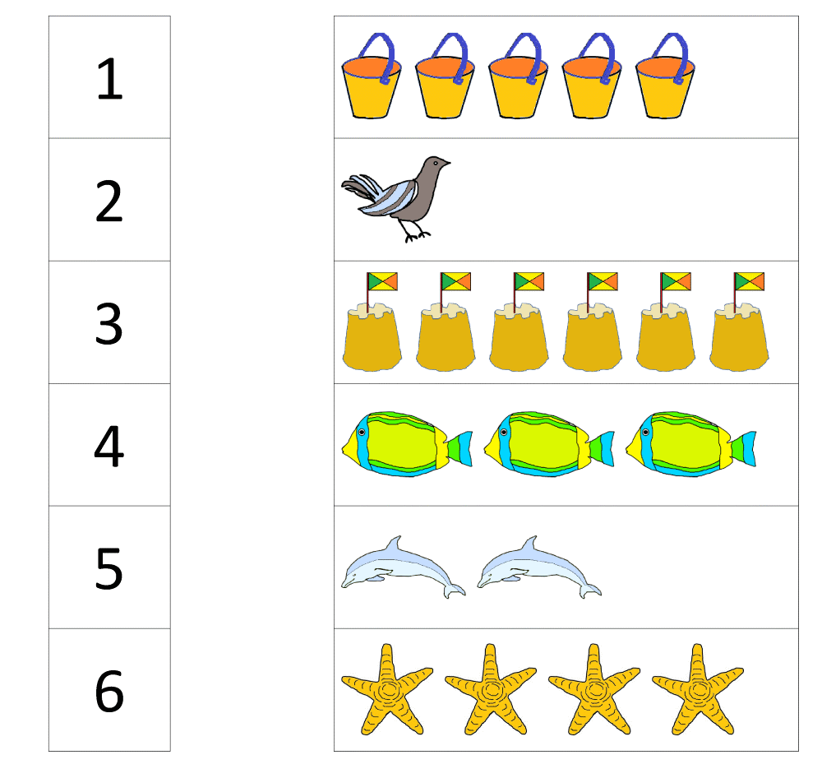

Group 2

Trace the numbers

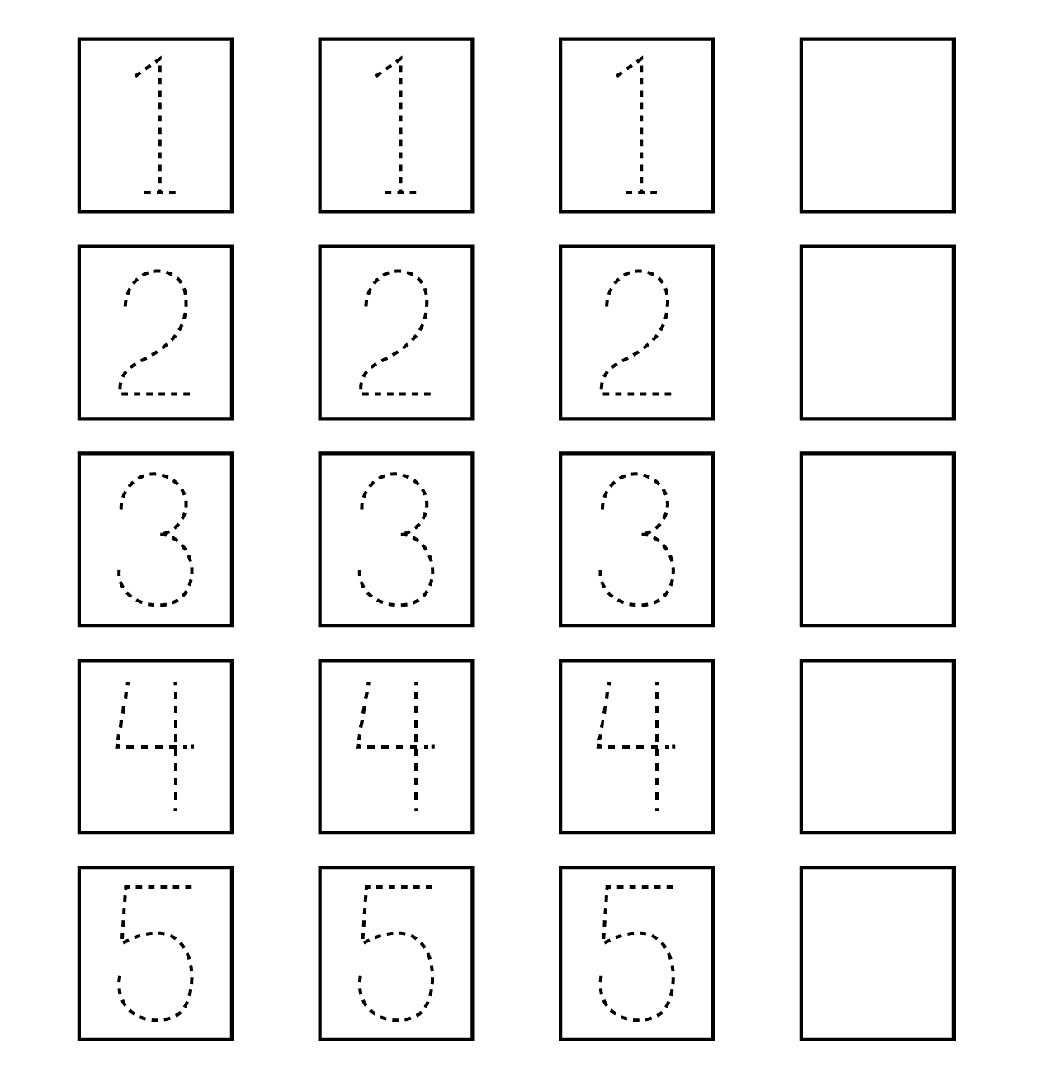

What comes next?
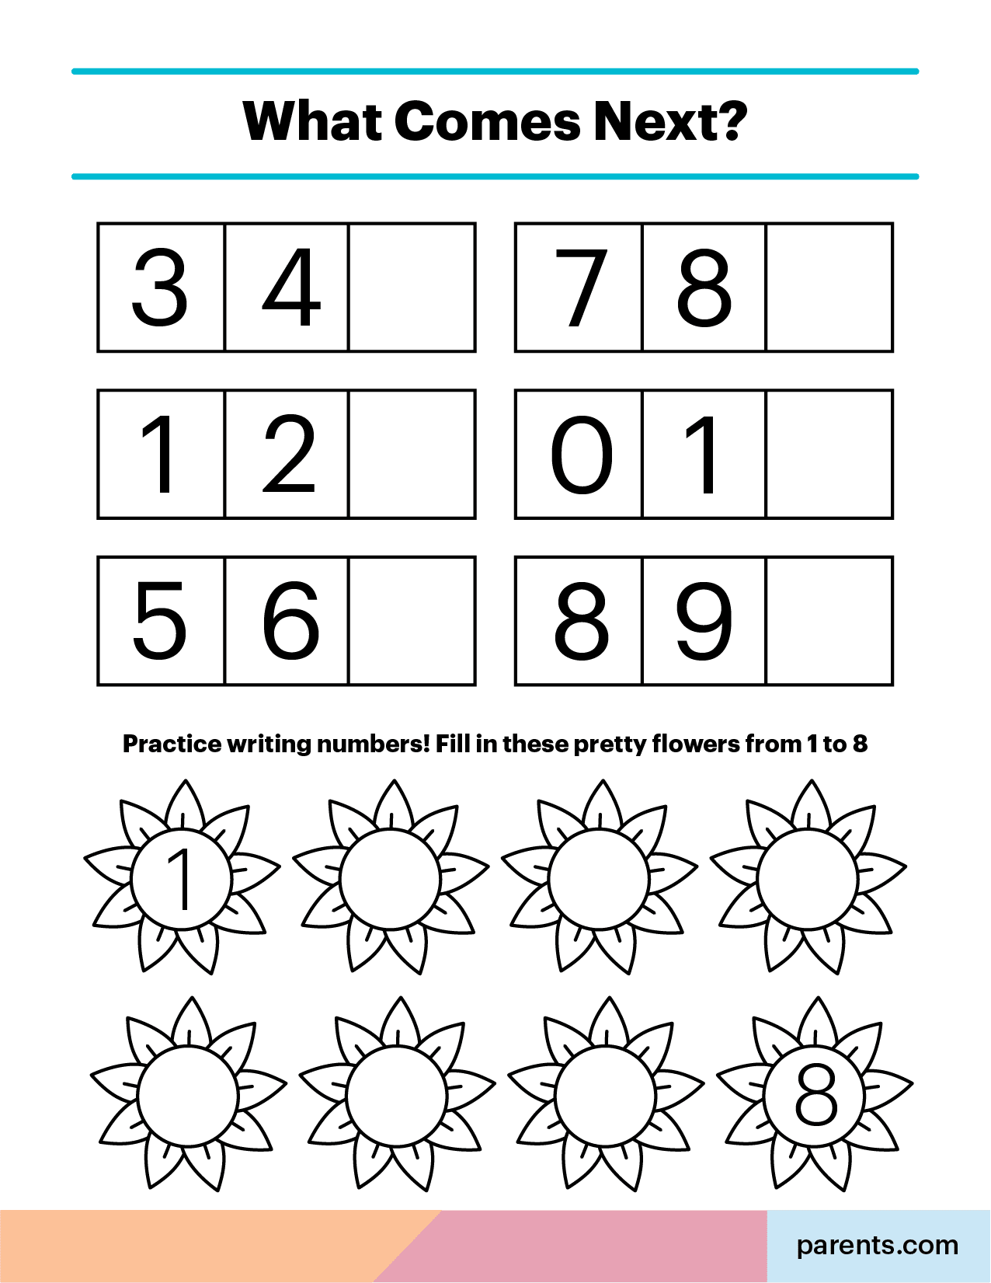

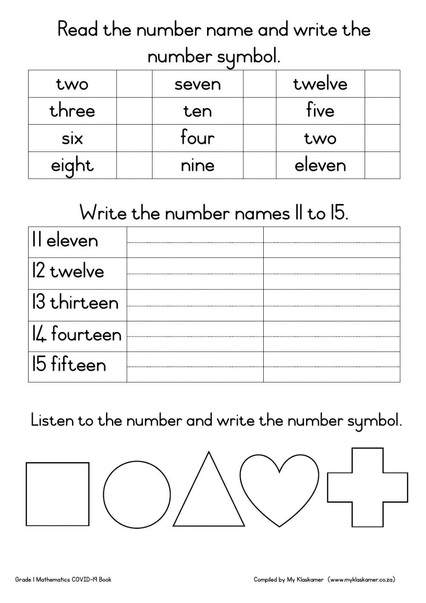
Group 3

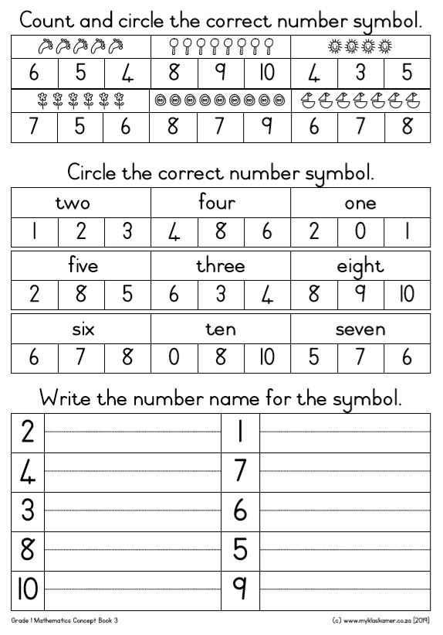
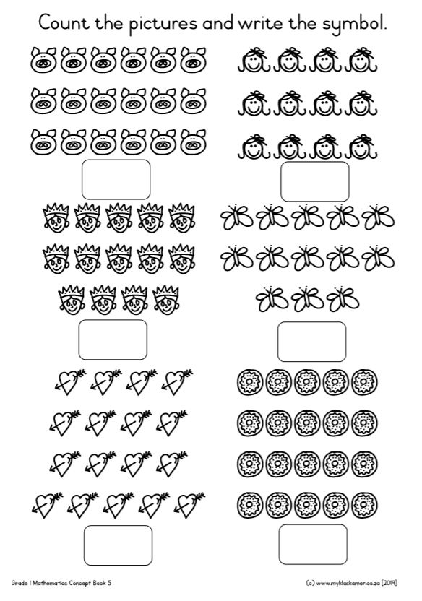

Missing letters
Fill in the missing numbers

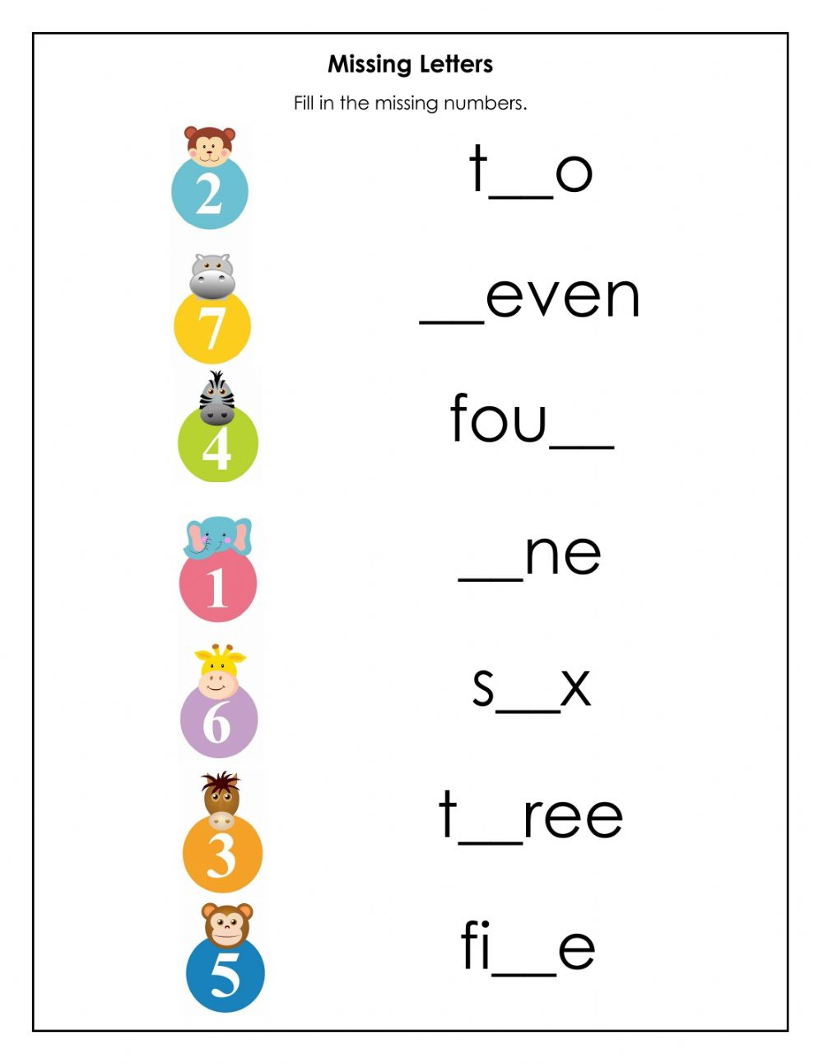
Week 3

Group 1

Trace the number 8 and colour
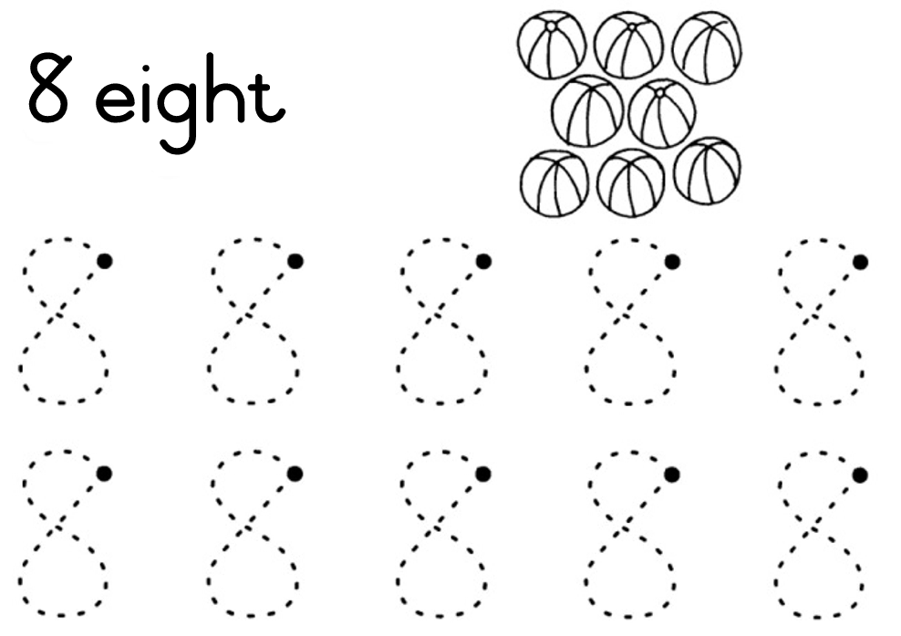

Trace the numbers

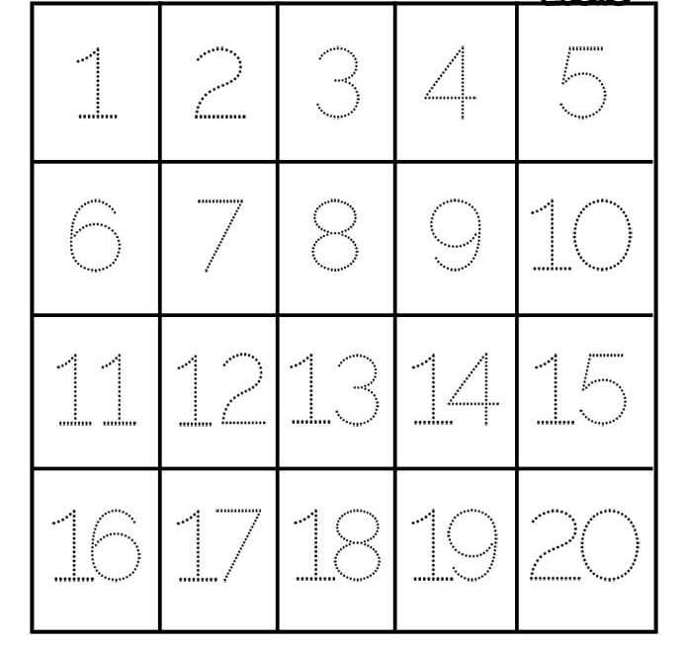

Group 2

fill in the missing numbers in order.

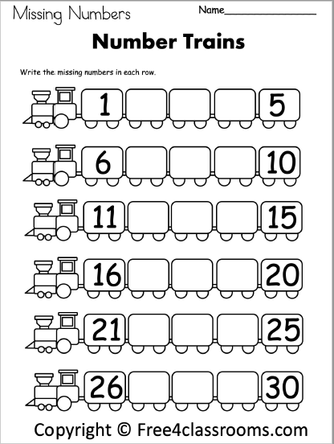

Order the numbers
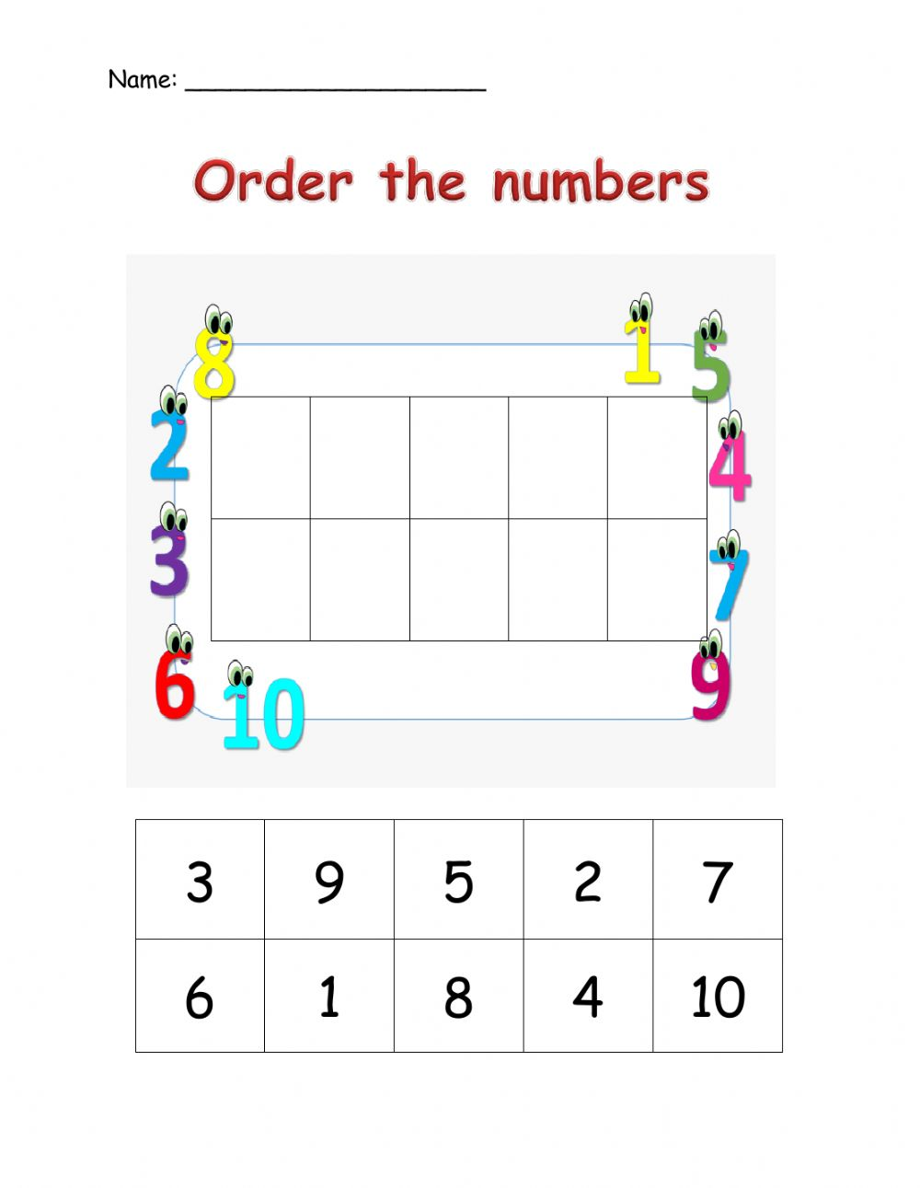

Greater than/less than
Compare the groups in each row an write the correct sign in the middle

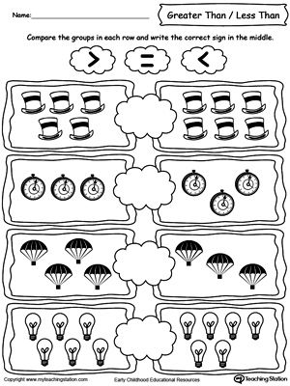

Group 3

Describe, compare and order numbers.
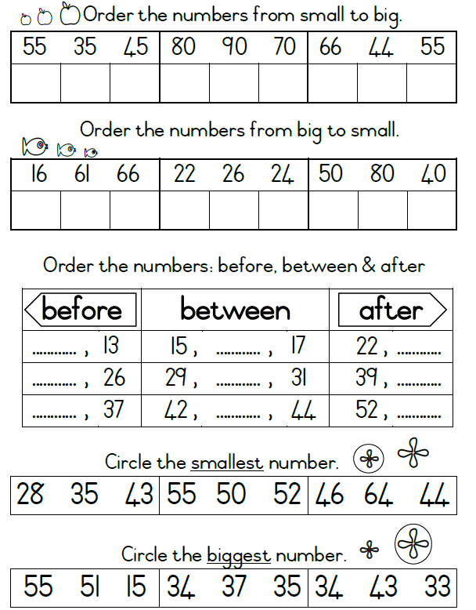

Describe, order and compare

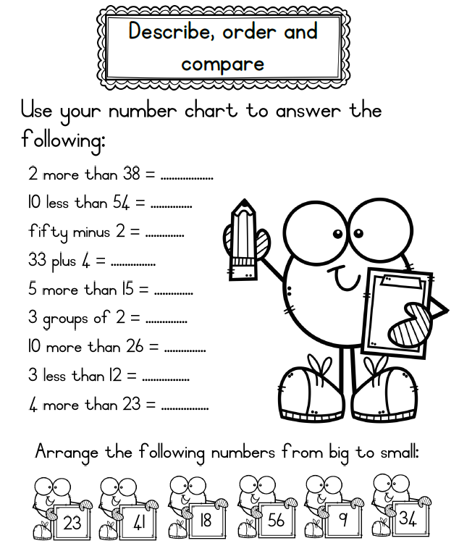

Write down the numbers in order from least to greatest.
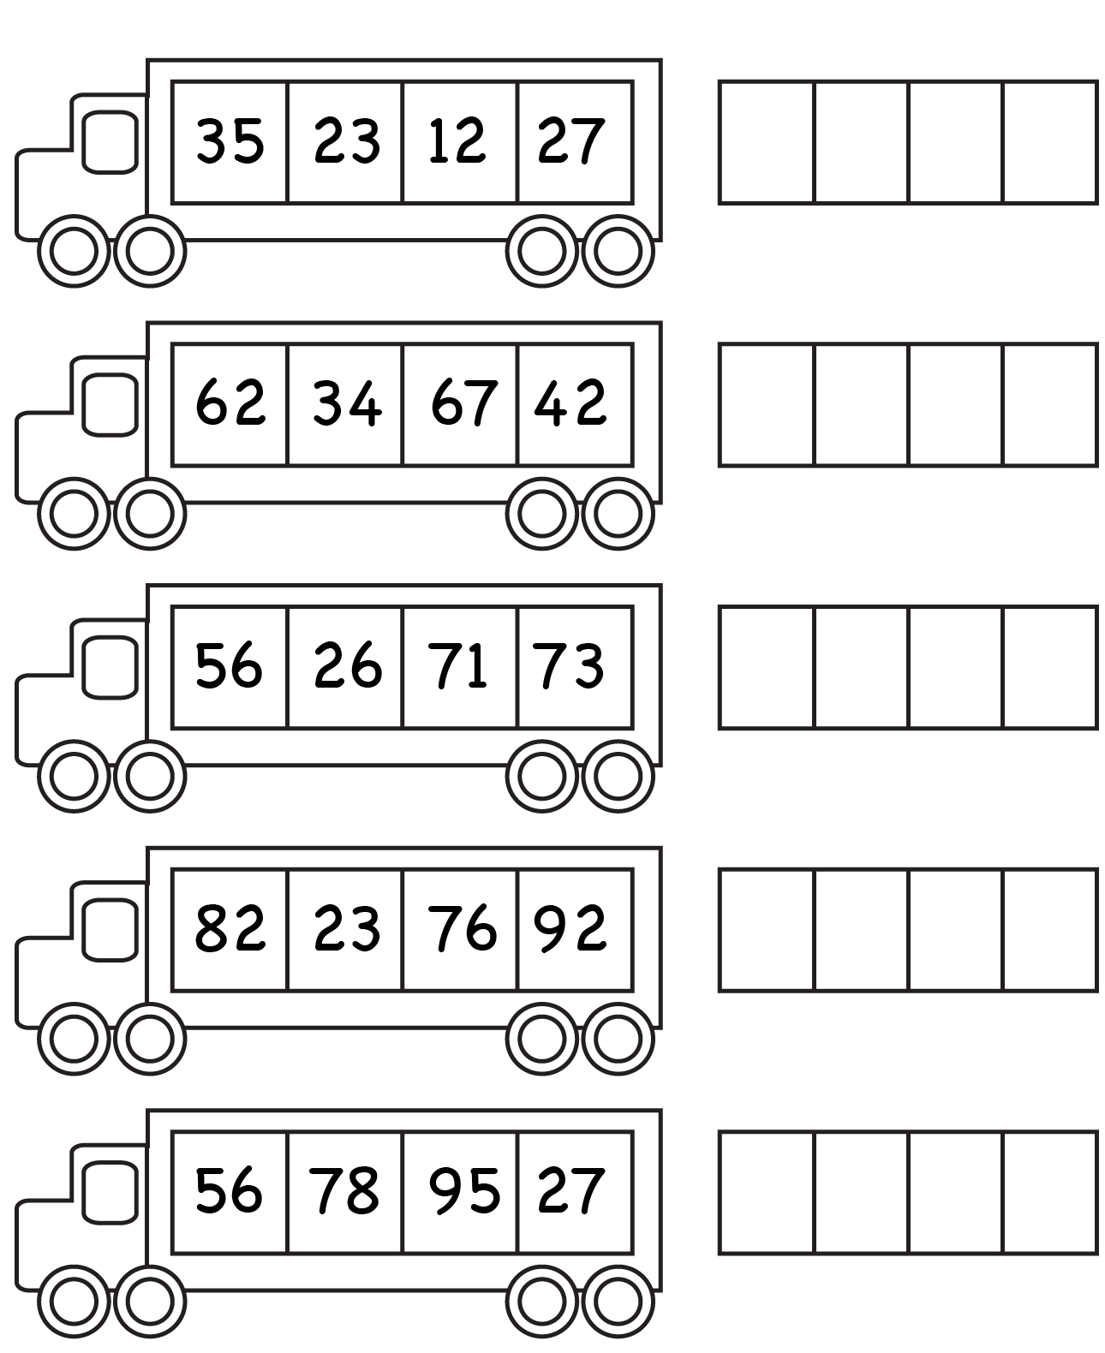
Week 4

Group 1

Recognise South African money
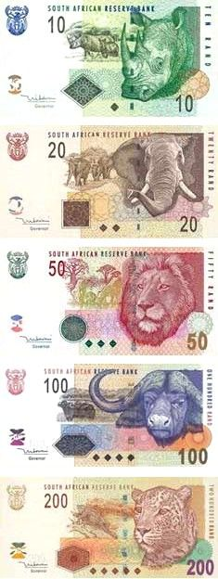

Recognise South African coins
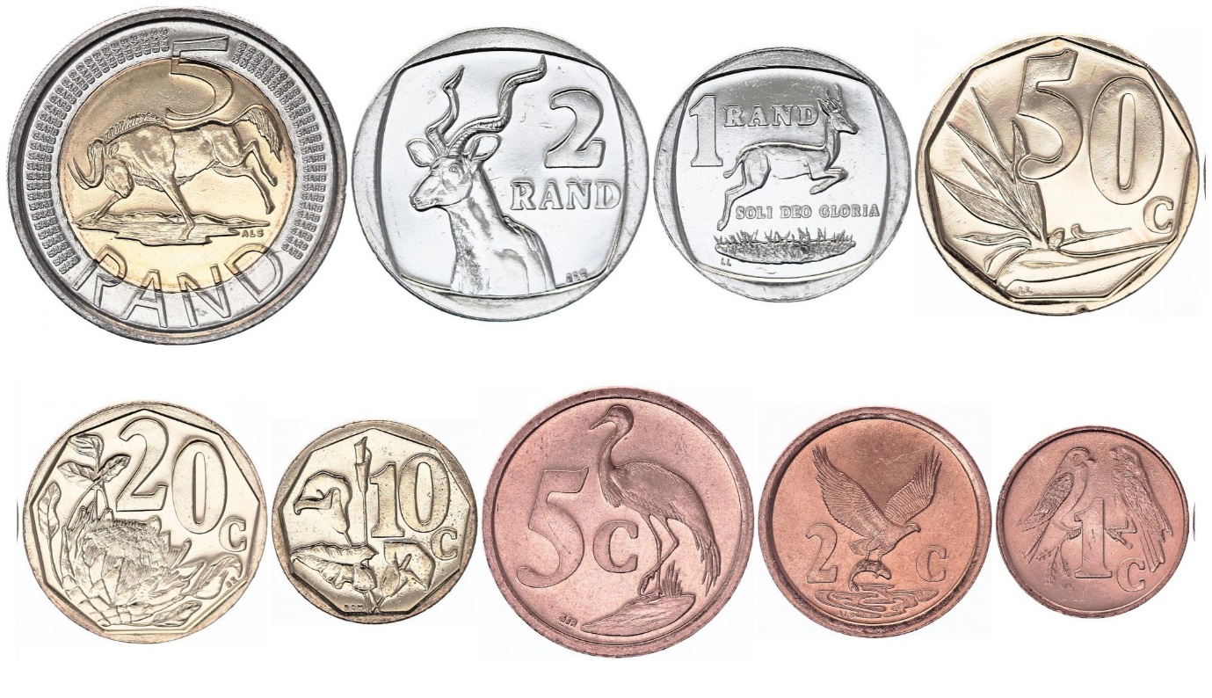

Identify coins and their names
Draw a line to match with its name

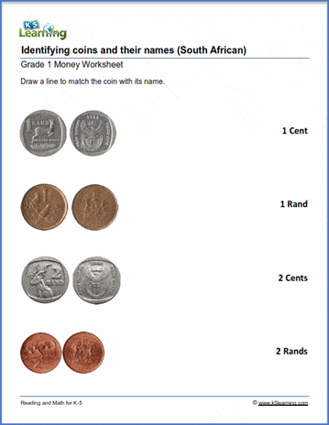

Group 2

South African money.
Add the coins together and write the answer in rands.
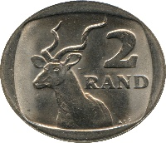 $+$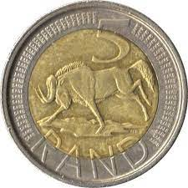 $+$ 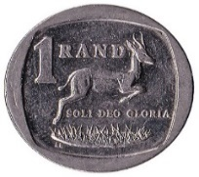$=$R
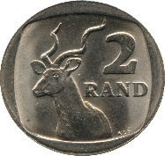 $+$ $+$ 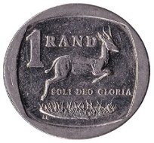 $+$ $=$R
$+$ $+$ 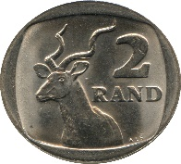 $+$ $=$R
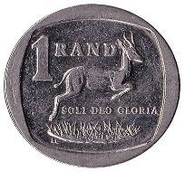 $+$ $+$ $+$ $=$R

Group 3

Add the coins together and write the answer in rands and cents
$+$ $+$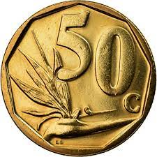$=$R
$+$ $+$ $+$$=$R
$+$ $+$ $+$$=$R
$+$ $+$ $+$ $=$R
